Experiment - 12
Implementing Security Features and Governance / Administration Practices in Zoho Creator
SAI PRANAV B.V.
241401088 CSBS
AIM
To implement and explore the security, access-control, and governance/administration features of a Zoho Creator application.
INTRODUCTION
Security and governance in low-code applications involve controlling who can access an application, what operations users are permitted to perform, and how application data and resources are administered.
Zoho Creator provides built-in mechanisms for managing application access and administration. User permissions determine the operations that users can perform on application components, while administrative settings help control and manage the application. These mechanisms help ensure that users receive appropriate access and that application data is protected from unauthorized use.
APPLICATION USED
The practical was carried out using the Patient Appointment & Scheduling Management application.
The application is used to manage patient appointment bookings, appointment details, appointment status, departments, and confirmation notifications. Since the application handles appointment-related information, controlling access to the application and its data is an important part of application administration.
SECURITY AND GOVERNANCE ARCHITECTURE
The security and governance structure of the application can be represented conceptually as follows:
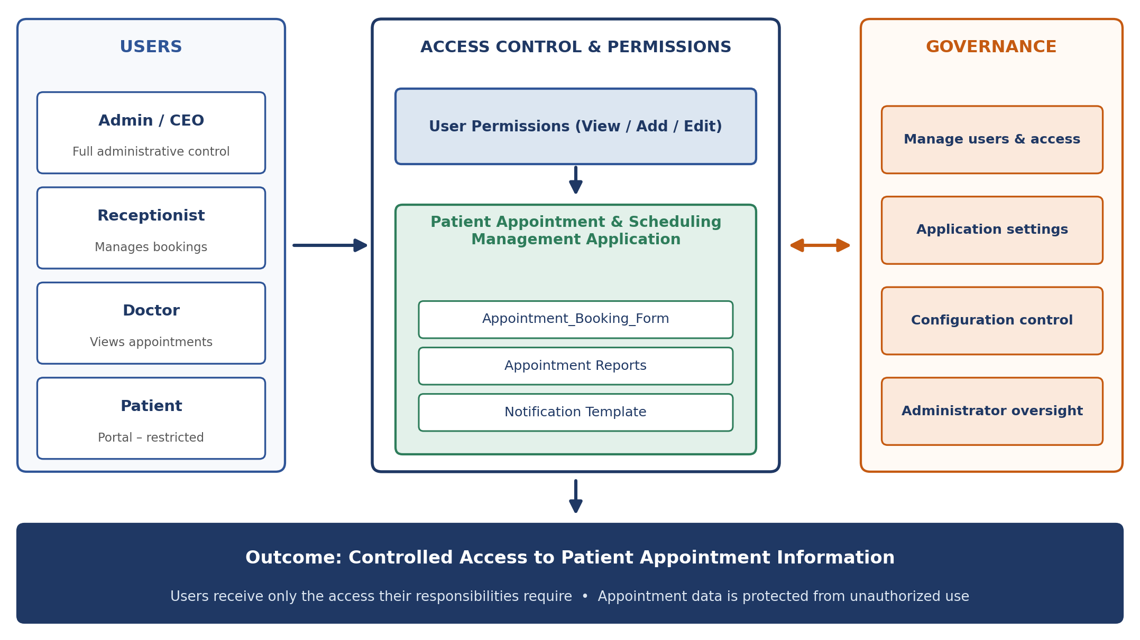
Figure 1: Security and Governance Architecture of the Patient Appointment Management Application (Conceptual Diagram)
The diagram represents how users access the application through defined permissions and how access control helps protect the application's forms, reports, and appointment data. It is a conceptual representation and is not a screenshot of the Zoho Creator interface.
USER PERMISSIONS
User permissions are used to control what users can do within the application. Permissions can determine whether users are allowed to view or modify application components and records.
For the Patient Appointment & Scheduling Management application, access should be provided according to the responsibilities of the users. Users who only need to view appointment information can be provided appropriate read access, while users responsible for managing appointment records may require write access.
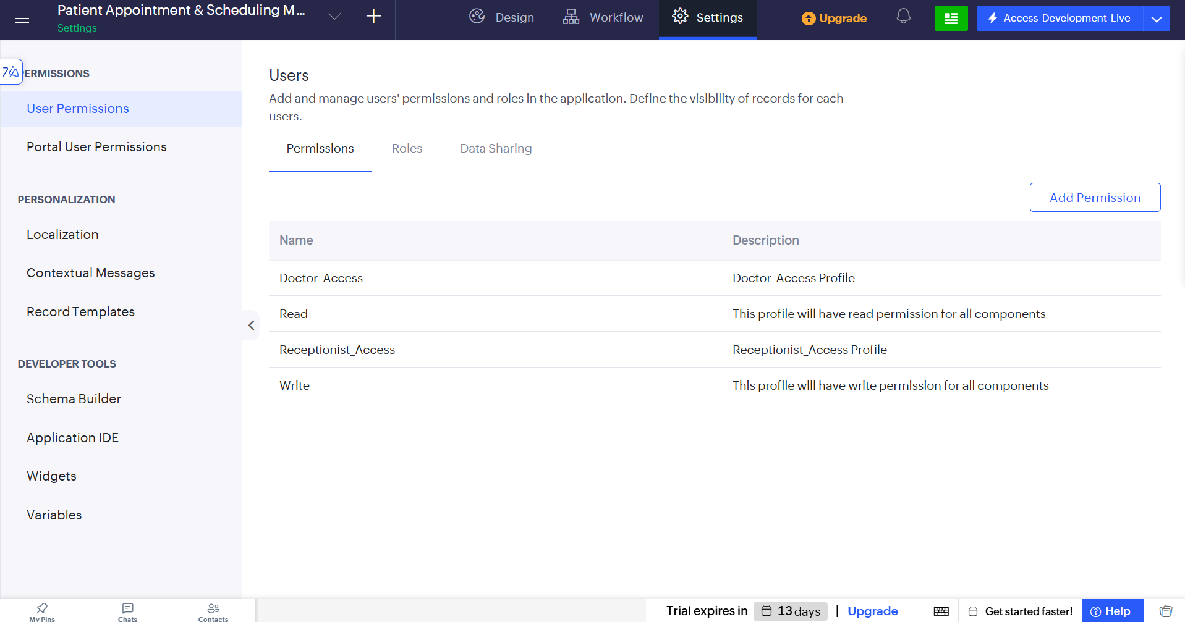
Figure 2: User Permissions in the Patient Appointment & Scheduling Management Application

The permission configuration provides controlled access to application components and helps prevent users from performing operations beyond their responsibilities.
GOVERNANCE AND ADMINISTRATION
Application governance involves managing the application configuration, access settings, users, and other administrative controls. These controls help maintain the application in an organized and secure manner.
The administrator is responsible for managing access to the application and maintaining the configuration of the application according to its requirements.
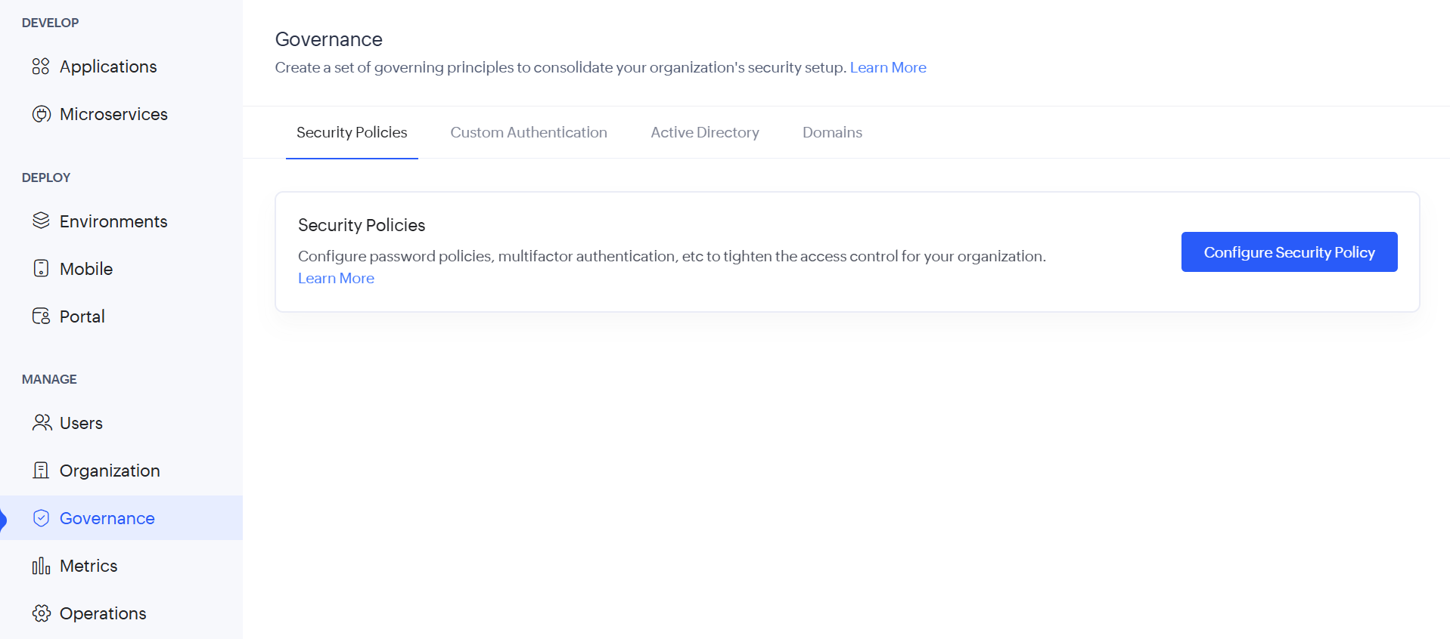
Figure 3: Application Administration and Governance Settings

The administration controls help manage the application and ensure that access and configuration are maintained appropriately.
SECURITY ACCESS FLOW
The security process can be represented conceptually as:
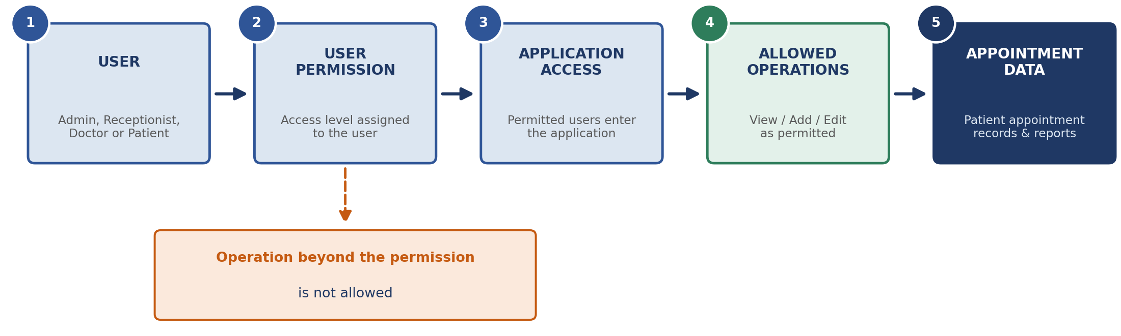
Figure 4: Security Access Control Flow (Conceptual Diagram)
The flow shows that access to appointment information is controlled through user permissions before the user can perform permitted operations on the application data.
GOVERNANCE AND ADMINISTRATION FLOW
The overall governance process can be represented as:
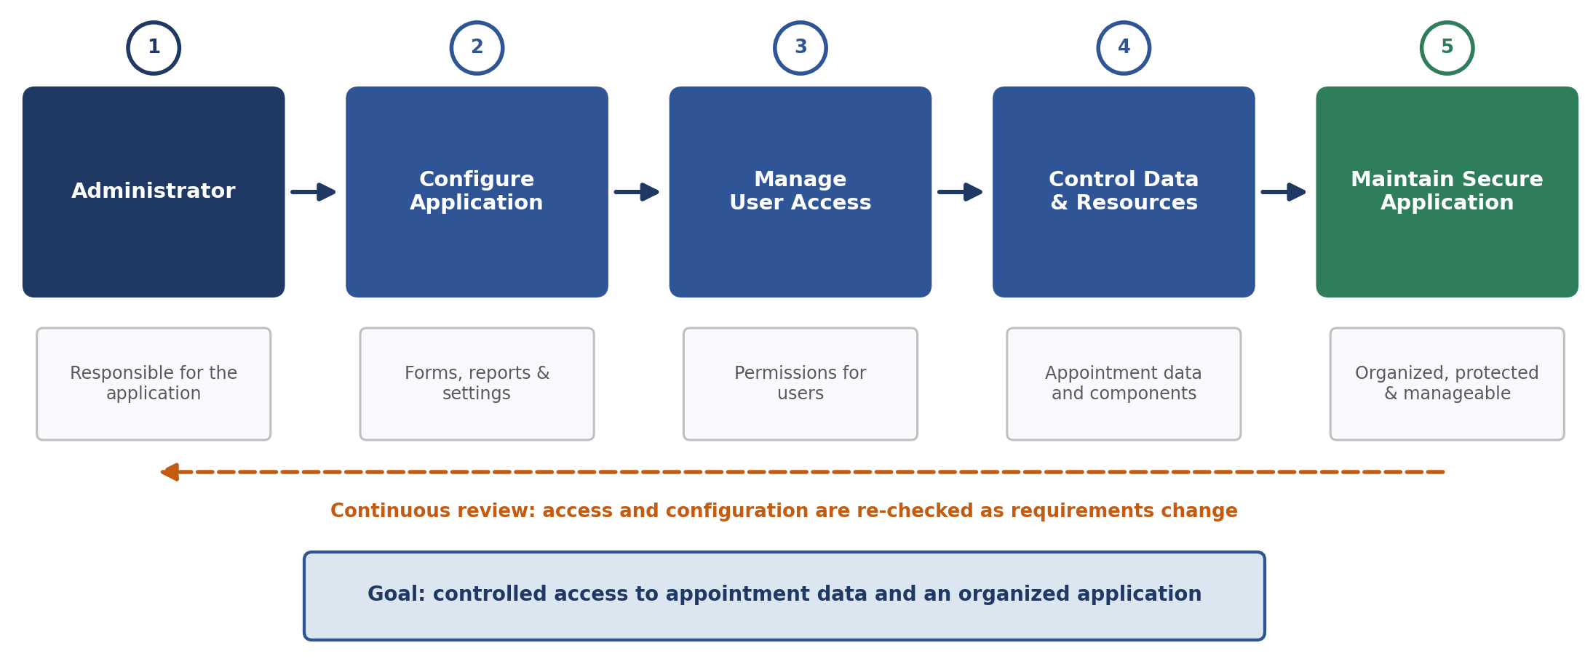
Figure 5: Governance and Administration Flow (Conceptual Diagram)
This conceptual flow represents the administrative responsibilities involved in maintaining controlled access and managing the application.
SECURITY AND GOVERNANCE OBSERVATIONS
- User permissions provide controlled access to application components and data.
- Access levels can be aligned with the responsibilities of different users.
- Administrative settings provide mechanisms for managing the application.
- Controlled access helps protect appointment information from unauthorized use.
- Governance practices help maintain the application in an organized and manageable manner.
- Conceptual security and governance controls represent the intended access structure and should not be treated as proof that every available Zoho Creator security feature has been configured.
RESULT
The security and governance features of the Patient Appointment & Scheduling Management application were explored and applied to control application access and administration. The conceptual security architecture and access flows demonstrate how permissions and administrative controls help protect application data and maintain controlled use of the application.

